1 2 3 4 5 6 7 8

## A Section B-B (1:4) B

B 4mm [.16in] B

71mm [2.8in]

C

75mm [2.95in]

# A A

D

A

B

|  |  |  |
| --- | --- | --- |
|  | |  |
| C | |  |
|  |  |
| C | |  |

C

16mm [.63in]

## Section C-C (1:1) D

### Drawer Fronts:

Drawer fronts will have a minimum

of 50mm (1-15/16”) center flat panel.

1. Drawer fronts less than 200mm (7-7/8”) may have reduced rails and a 1-piece door design (pocketed center flat panel).

19mm [.75in]

13mm [.5in]

Drawer fronts less than 150mm (5-15/16") overall

## Section A-A (1:4)

Dept. Technical reference

Created by

E

Mullion Details

Approved by

will be slabs with no center flat panel.

### Mullion Details:

Sales

N/A

Engineering

Document type

Sales Blueprint

Title

11/4/2021

Sales

Document status

Released

DWG No.

12/1/2021

1. Available in 1, 3, 4 and 6 lites as standard offering.

Other customizations availabe to request

# NORTE - QUITO

NORTE - 014 F

Rev. Date of issue Sheet

A 1/3/2022 1/1

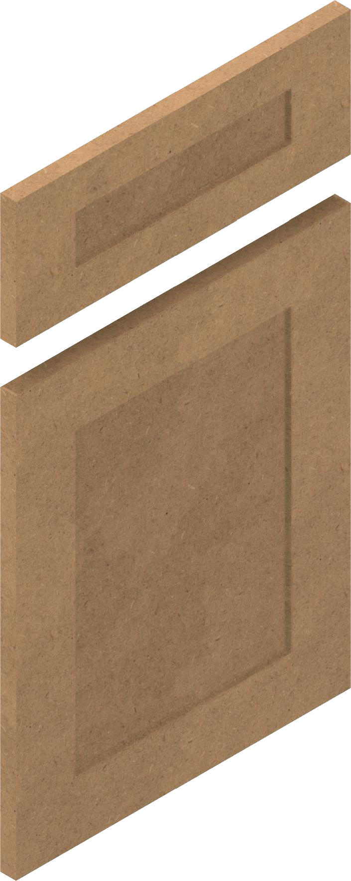

16mm [.63in]

1 2 3 4 5 6 7 8