1 2 3 4 5 6 7 8

# A Section B-B (1:4) B A

8.05mm [.32]

1. B B

# C

1. 75mm [2.95in] C C

20mm [.79in]

# A A

1. D

# Section

C-C (1:1)

20mm [.79in]

## Drawer Fronts:

Drawer fronts will have a minimum of 50mm (1-15/16”) center flat panel.

1. Drawer fronts less than 200mm (7-7/8”) may have reduced rails and a 1-piece door design (pocketed center flat panel).

# Section A-A (1:4)

55mm [2.17in]

E

Mullion Details

Drawer fronts less than 150mm (5-15/16") overall will be slabs with no center flat panel.

## Mullion Details:

Dept.

Sales

Technical reference

N/A

Created by

Engineering

Document type

Sales Blueprint

Title

11/4/2021

Approved by

Sales

Document status

Released

DWG No.

12/1/2021

1. Available in 1, 3, 4 and 6 lites as standard offering.

Other customizations availabe to request

# NORD - PISA VV

NORD - 006 F

Rev. Date of issue Sheet

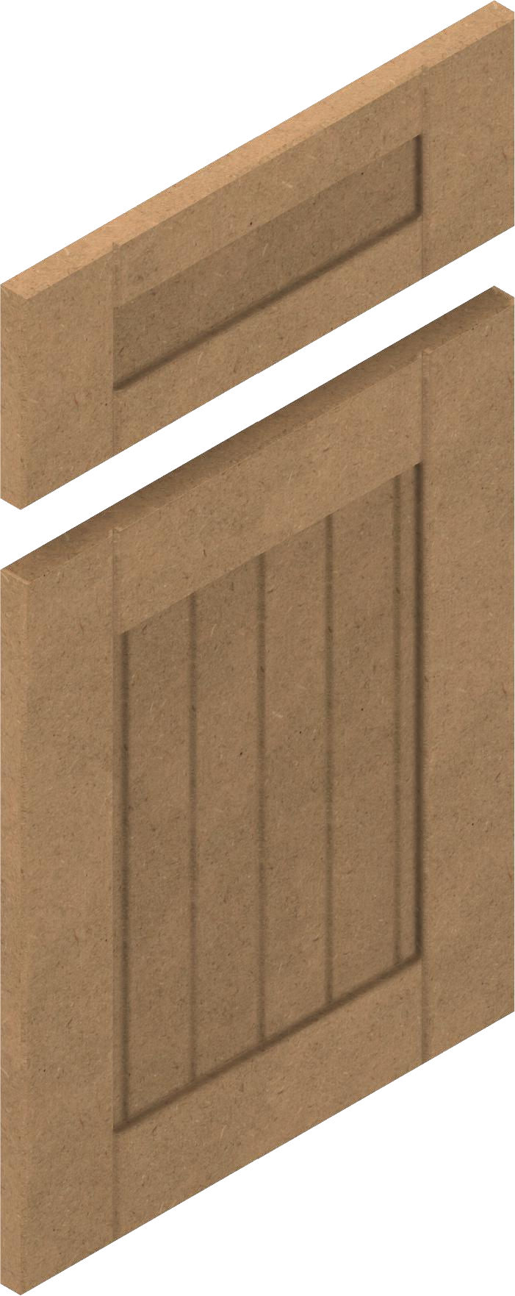

1 2 3 4

5 6 7

19.05mm [.75in]

8.05mm [.32in]

A 1/3/2022

1/1

8