1 2 3 4 5 6 7 8

# A Section B-B (1:4 ) B A

1. B B
2. C

# A A

65mm [2.56in]

1. D

Reference Cross-Section:

Nord - Oslo, For 3, 4 and 6 lites

# E Section A-A (1:4 )

E

Mullion Details

22mm [.88in]

12mm [.5in]

## Drawer Fronts:

Drawer profile to match door profile

## Mullion Details:

Dept.

Sales

Technical reference

N/A

Created by

Engineering

Document type

Sales Blueprint

Title

11/4/2021

Approved by

Sales

Document status

Released

DWG No.

12/1/2021

F Available in 1 lite as standard offering.

Other customizations availabe to request

# NORDEN - HAGUE

NORDEN - 004 F

Rev. Date of issue Sheet

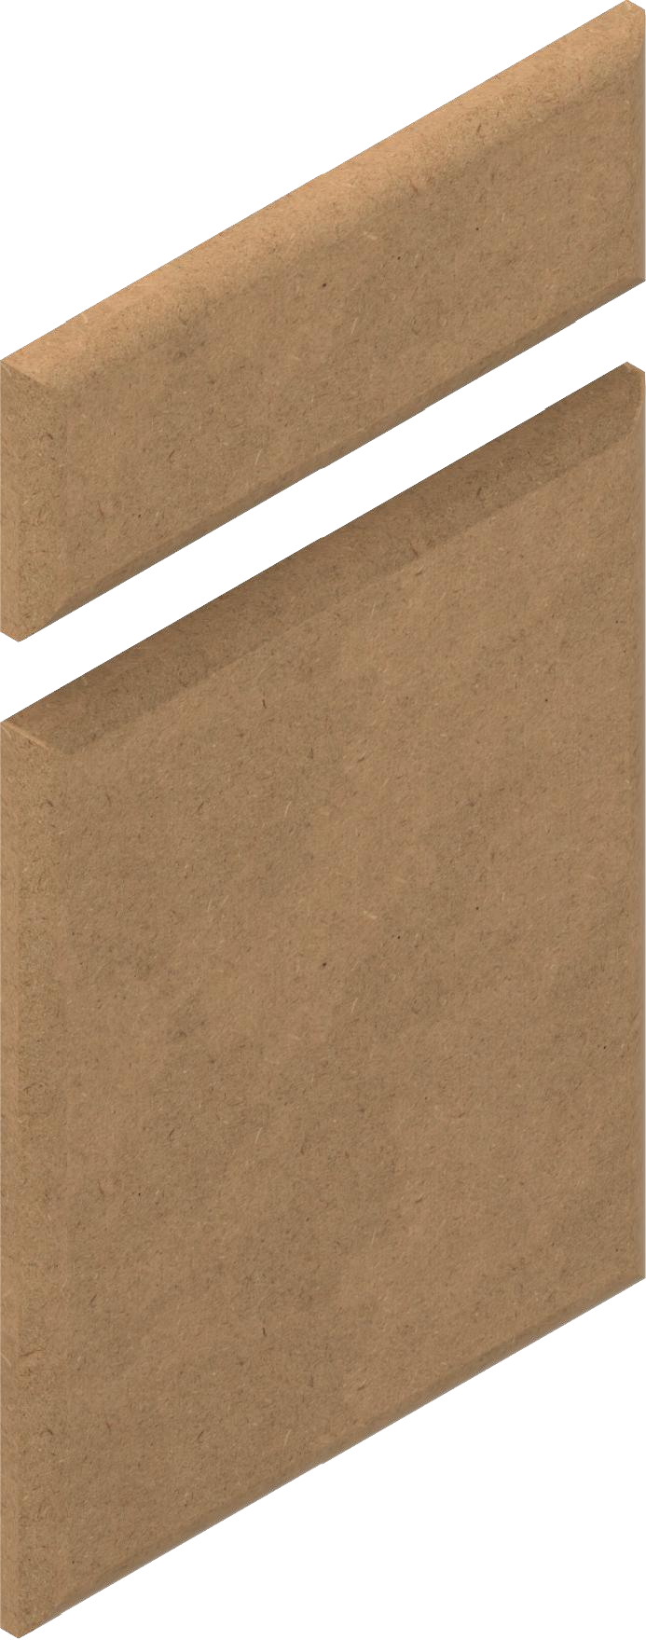

1 2 3 4

5 6 7

A 1/3/2022

1/1

8