1 2 3 4 5

# Section B-B (1:4)

12.5mm [.49in]

B

A

B 10.5mm [.41in] B

6 7 8

A

B

# C

C

C 80mm [3.15in]

67.5mm [2.66in]

# A

D

## Drawer Fronts:

Drawer fronts will have a minimum of 50mm (1-15/16”) center flat panel.

1. Drawer fronts less than 200mm (7-7/8”) may have

reduced rails and a 1-piece door design (pocketed center flat panel).

19mm [.75in]

6mm [.25in]

# A

Section A-A (1:4)

C

18mm [.71in]

# Section C-C (1:1) D

18mm

E

Mullion Details

Drawer fronts less than 150mm (5-15/16") overall will be slabs with no center flat panel.

## Mullion Details:

Dept.

Sales

Technical reference

N/A

Created by

Engineering

Document type

Sales Blueprint

Title

11/4/2021

Approved by

Sales

Document status

Released

DWG No.

12/1/2021

1. Available in 1, 3, 4 and 6 lites as standard offering.

Other customizations availabe to request

# NORTE - CAYENNE

NORTE - 004 F

Rev. Date of issue Sheet

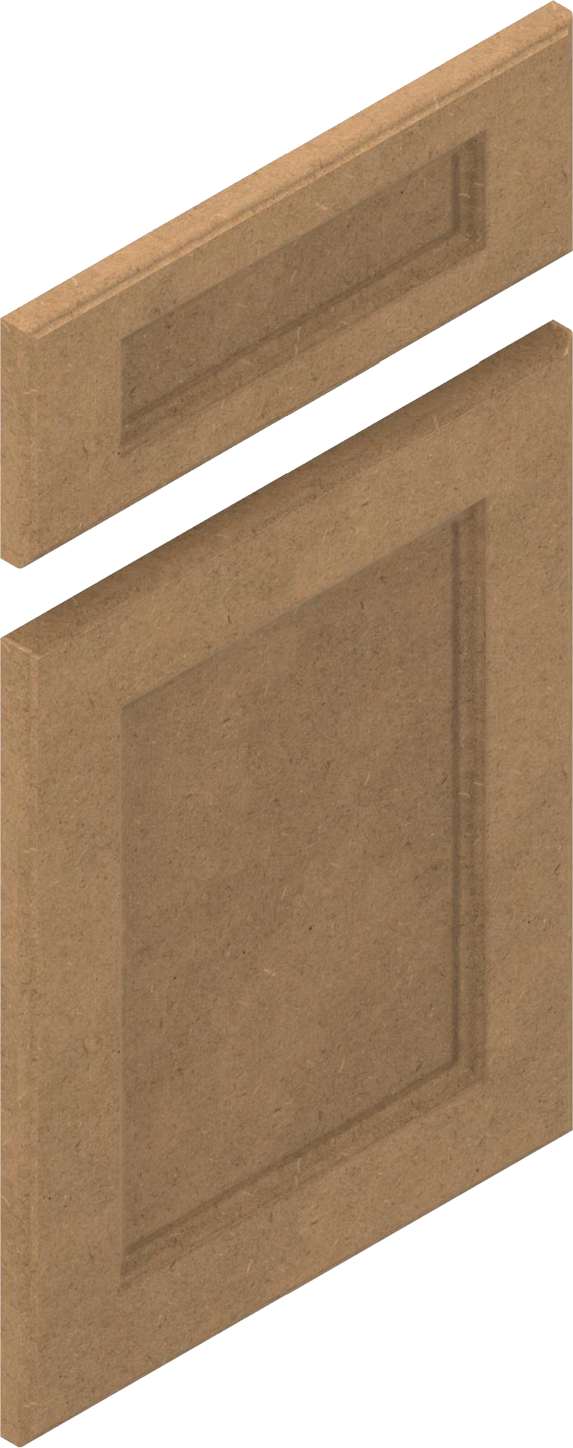

1 2 3 4

5 6 7

A 1/3/2022

1/1

8