1 2 3 4 5 6 7 8

## A Section B-B (1:4) B A

B B

|  |  |  |
| --- | --- | --- |
| C | |  |
|  |  |
|  |

11mm [.44in] B

## C

C

80mm [3.15in] 62mm [2.44in]

## A

D

C

## A

25

D

## Section C-C (1:1)

25mm [1in]

### Drawer Fronts:

Drawer fronts will have a minimum of 50mm (1-15/16”) center flat panel.

1. Drawer fronts less than 200mm (7-7/8”) may have reduced rails and a 1-piece door design (pocketed center flat panel).

Section A-A (1:4)

# Mullion

19mm [.75in]

6mm [.25in]

E

# Details

Drawer fronts less than 150mm (5-15/16") overall will be slabs with no center flat panel.

### Mullion Details:

Dept.

Sales

Technical reference

N/A

Created by

Engineering

Document type

Sales Blueprint

Title

11/4/2021

Approved by

Sales

Document status

Released

DWG No.

12/1/2021

1. Available in 1, 3, 4 and 6 lites as standard offering.

Other customizations availabe to request

NORTE - ELVAS

NORTE - 006 F

Rev. Date of issue Sheet

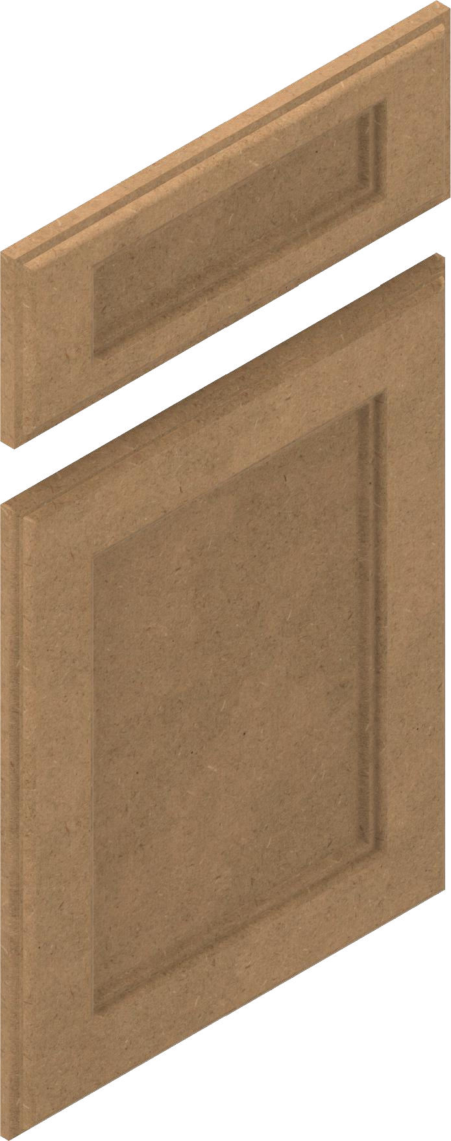

1 2 3 4

5 6 7

A 1/3/2022

1/1

8