1 2 3 4 5 6 7 8

1. A

B

1. B

# B

1. C

12.64mm [.5in]

63.5mm [2.5in]

# A A

1. D

**Drawer Fronts:**

Drawer fronts will have a minimum of 50mm (1-15/16”) center flat panel.

1. Drawer fronts less than 200mm (7-7/8”) may have reduced rails and a 1-piece door design (pocketed center flat panel).

# Section B-B (1:2)

E

Mullion Details

Drawer fronts less than 150mm (5-15/16") overall will be slabs with no center flat panel.

**Mullion Details:**

# Section A-A (1:3)

Dept.

Sales

Technical reference

N/A

Created by

Engineering

Document type

Sales Blueprint

Title

11/4/2021

Approved by

Sales

Document status

Released

DWG No.

12/1/2021

1. Available in 1, 3, 4 and 6 lites as standard offering.

Other customizations availabe to request

# NORD - HOLKN

NORD - 002 F

Rev. Date of issue Sheet

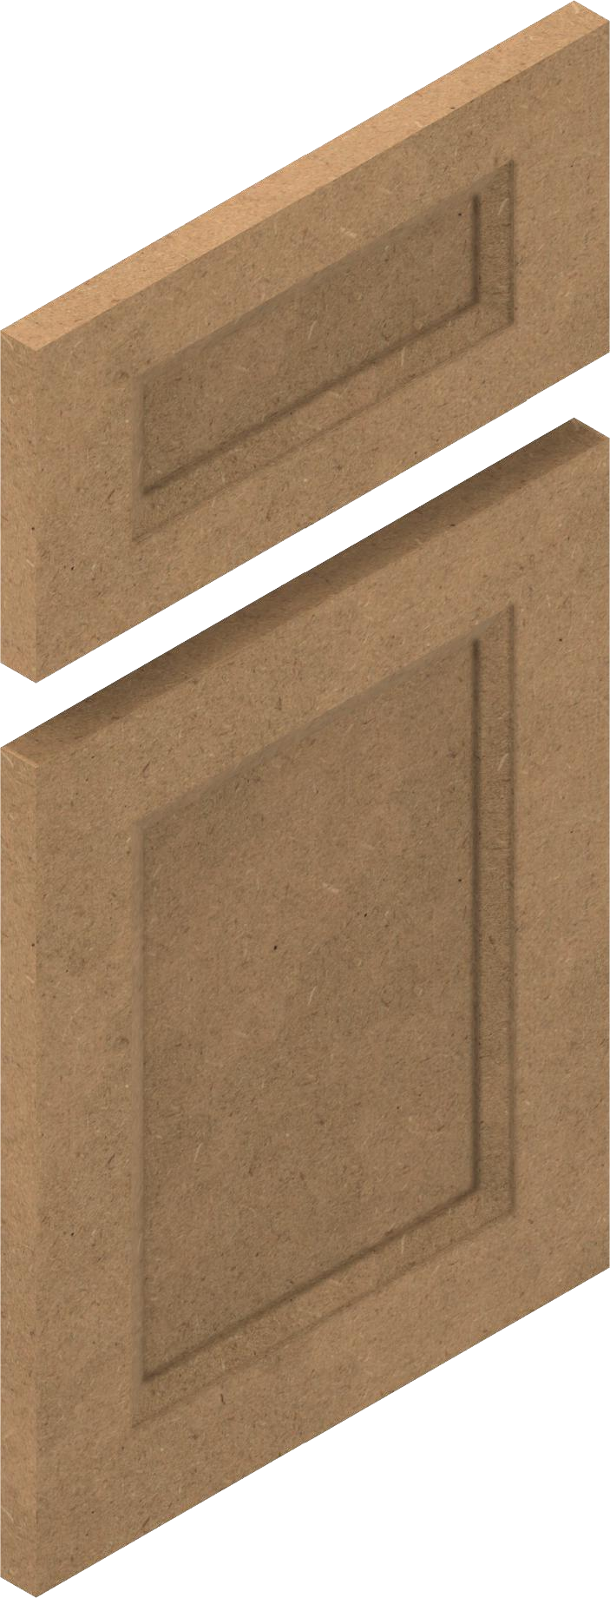

1 2 3 4

5 6 7

A 1/3/2022

1/1

8