1 2 3 4 5 6 7 8

# B

1. A
2. B

# B-B (1:3) B

1. C

# C C

A A

1. D

**Drawer Fronts:**

Drawer fronts will have a minimum

of 50mm (1-15/16”) center flat panel.

1. Drawer fronts less than 200mm (7-7/8”) may have reduced rails and a 1-piece door design (pocketed center flat panel).

Drawer fronts less than 150mm (5-15/16") overall

# Section

Dept. Technical reference

Created by

# Section C-C (1"2)

E

Mullion Details

Approved by

will be slabs with no center flat panel.

**Mullion Details:**

# A-A (1:3)

Sales

N/A

Engineering

Document type

Sales Blueprint

Title

6/30/2024

Sales

Document status

Released

DWG No.

6/30/2024

1. Available in 1, 3, 4 and 6 lites as standard offering.

Other customizations availabe to request

# NORDUR - COLONIAL

NORDUR - 002 F

Rev. Date of issue Sheet

A 6/30/2024 1/1

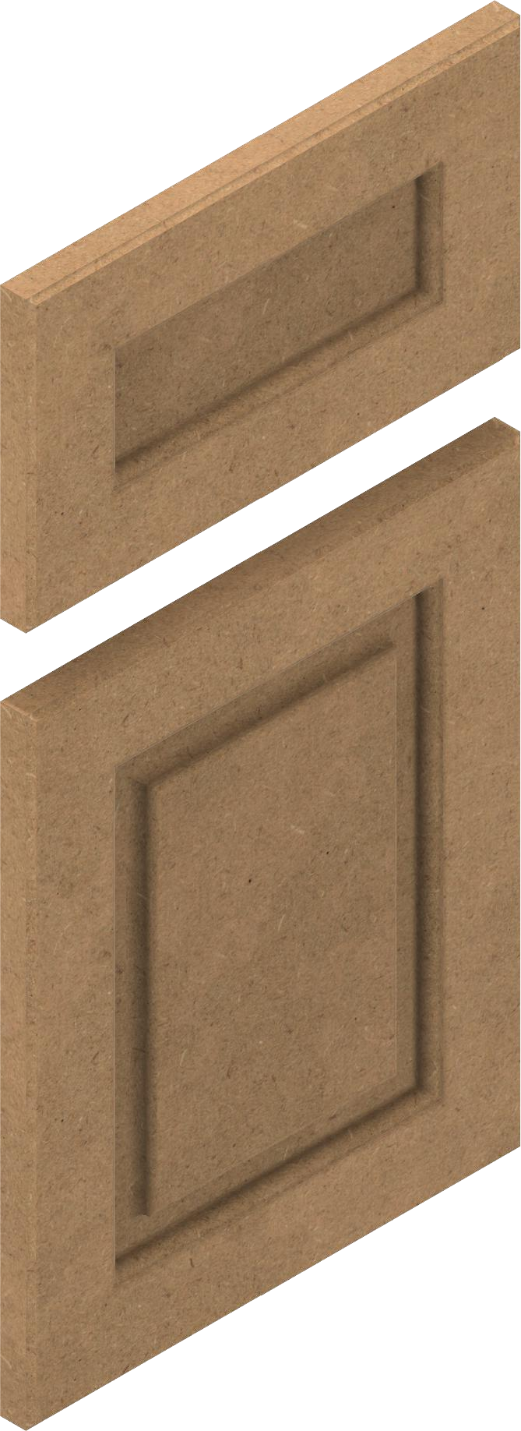

19.05mm [.75in]

1 2 3 4 5 6 7 8