1 2 3 4 5 6 7 8

1. A

B

1. B

15.5mm [.61in]

69.85mm [2.75in]

B

1. C

13.6mm [.54in]

# A A

1. D

1.5mm [.0591in]

## Drawer Fronts:

Drawer fronts will have a minimum

of 50mm (1-15/16”) center flat panel.

1. Drawer fronts less than 200mm (7-7/8”) may have reduced rails and a 1-piece door design (pocketed center flat panel).

135°

# Section A-A (1:3)

Dept. Technical reference

Created by

# Section B-B (1:2)

E

Mullion Details

Approved by

Drawer fronts less than 150mm (5-15/16") overall will be slabs with no center flat panel.

## Mullion Details:

Sales

N/A

Engineering

Document type

Sales Blueprint

Title

11/4/2021

Sales

Document status

Released

DWG No.

12/1/2021

1. Available in 1, 3, 4 and 6 lites as standard offering.

Other customizations availabe to request

# NORDUR - REYKJAVIK

NORDUR - 001 F

Rev. Date of issue Sheet

A 1/3/2022 1/1

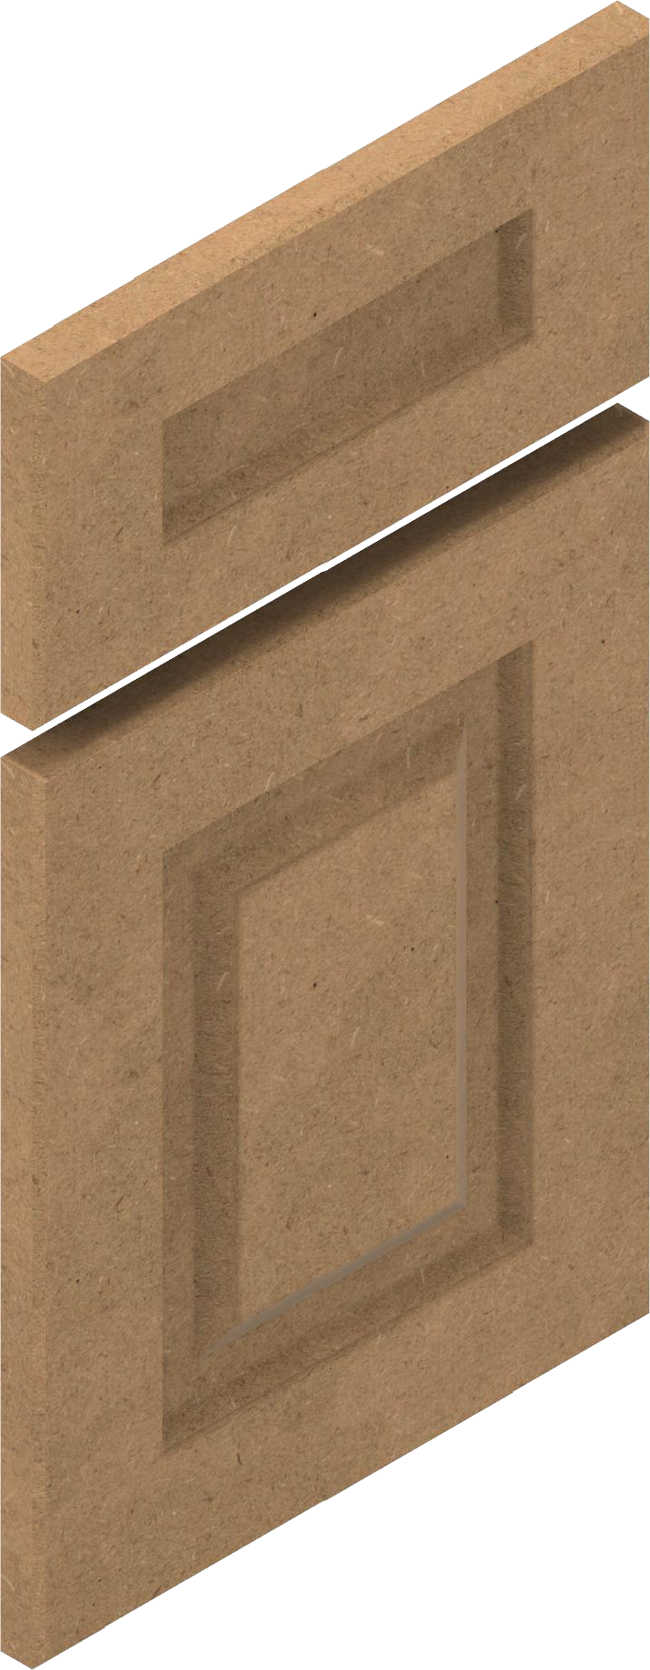

8.5mm [.33in]

19.05mm [.75in]

1 2 3 4 5 6 7 8