1 2 3 4 5 6 7 8

## A SectionB-B (1:4) B A

8mm [.32in]

1. B B

# C C

1. C

66mm [2.6in]

# A A

24mm [.94in]

1. D

## Section C-C (1:1)

24mm [.94in]

### Drawer Fronts:

Drawer fronts will have a minimum

of 50mm (1-15/16”) center flat panel.

1. Drawer fronts less than 200mm (7-7/8”) may have reduced rails and a 1-piece door design (pocketed center flat panel).

## Section A-A (1:4)

E

Mullion Details

Dept. Technical reference

19mm [.75in]

10mm [.37in]

Created by

Approved by

Drawer fronts less than 150mm (5-15/16") overall will be slabs with no center flat panel.

### Mullion Details:

Sales

N/A

Engineering

Document type

Sales Blueprint

Title

11/4/2021

Sales

Document status

Released

DWG No.

12/1/2021

1. Available in 1, 3, 4 and 6 lites as standard offering.

Other customizations availabe to request

NORD - Thule

# NORD - 007 F

Rev. Date of issue Sheet

A 1/3/2022 1/1

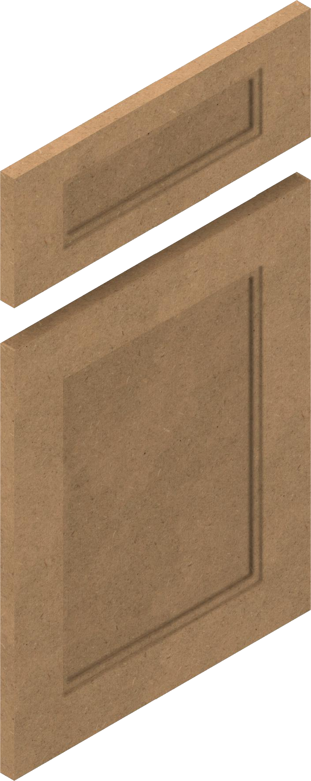

1 2 3 4 5 6 7 8